**Database Management Systems**

**Patient Management System**

**REPORT**

Table of Content:

Analysis 3

Methodology: 3

Implementation: 3

Conclusion: 3

# Analysis

* Summary and Objectives collected from the studied application.

SUMMARY:

The patient management system is a web-based application developed using .NET Framework and SQL Server. It aims to streamline the process of managing patient appointments, billing, electronic health records, and patient ward information. By automating these tasks, the system enhances workflow efficiency, improves data accuracy, and ultimately improves the overall patient experience. It requires the system users to log into the system to gain access to the features and functionalities of the system. Talking about the key features of this system is that this system will be able to insert, update, read and delete a particular record depend upon the requirement.

Objectives:

The main objectives of this system are:

**Patient Registration**: This allows user to register patient by entering his/her details and then allow to either delete, update or read patients details.

**Efficient Appointment:** The system allows healthcare professionals to schedule and manage patient appointments, facilitating easy appointment booking, rescheduling, and cancellation.

**Accurate Billing Generation**: The system automates the billing process, enabling accurate calculation of bill amounts based on services rendered, tracking payments, and generating itemized bills for patients.

**Comprehensive Electronic Health Records**: The system maintains electronic health records, including medical history, vital signs, lab reports, and prescribed medications. This facilitates centralized and accessible patient information for healthcare providers.

**Effective Patient Ward Management**: This manages patient ward information, including admission, discharge, bed availability, and occupancy tracking. This ensures efficient utilization of resources and enables timely patient care.

**Improved Communication and Collaboration**: This enhances communication and collaboration among healthcare providers by providing real-time access to patient information, facilitating better coordination and informed decision-making.

* Screenshots of main modules to be replicated

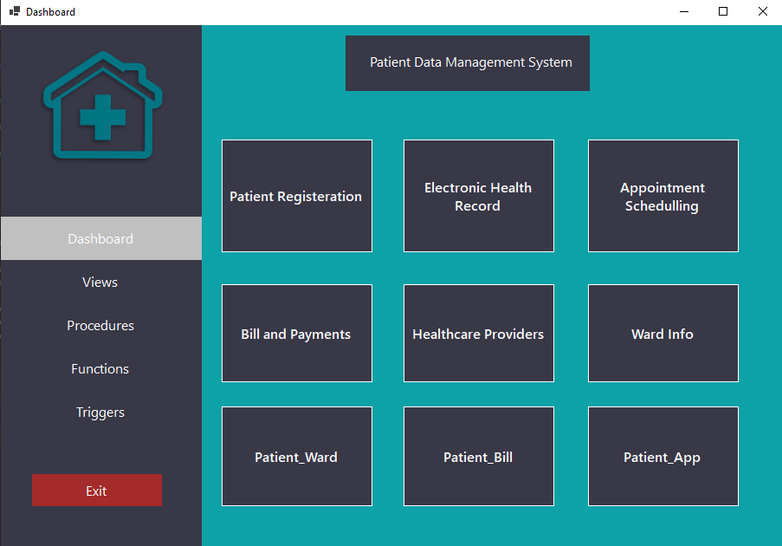

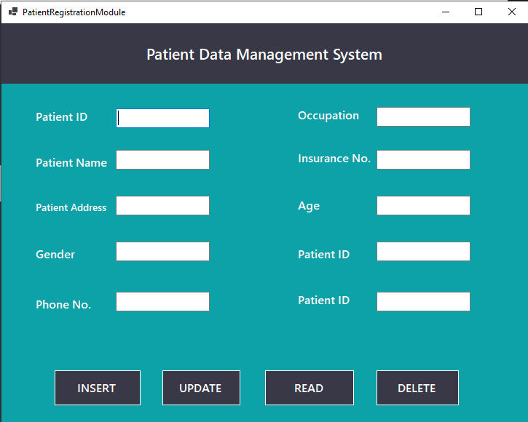

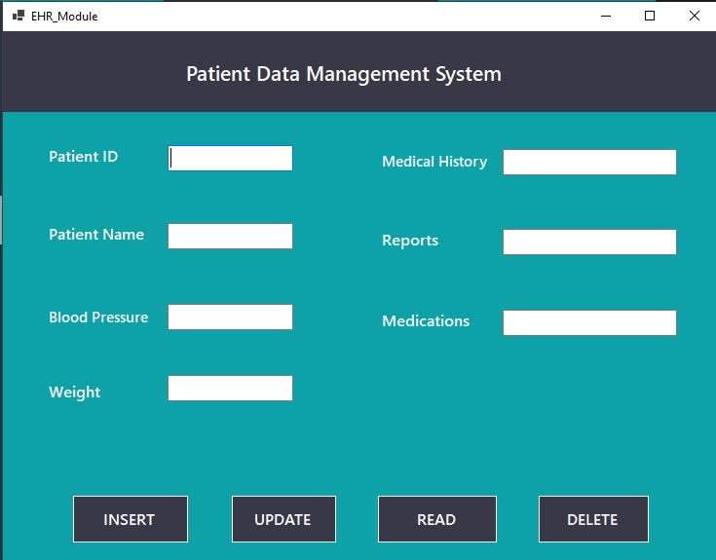

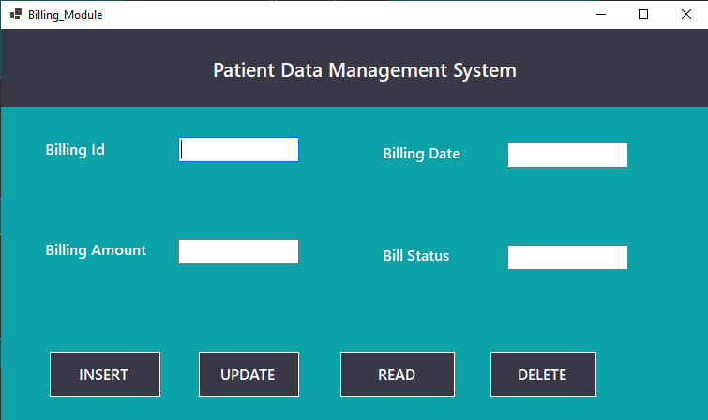

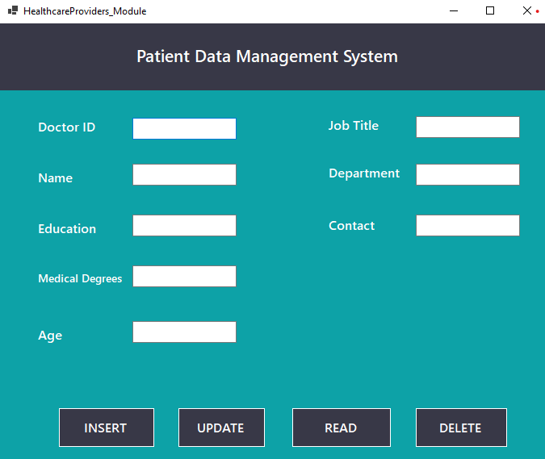

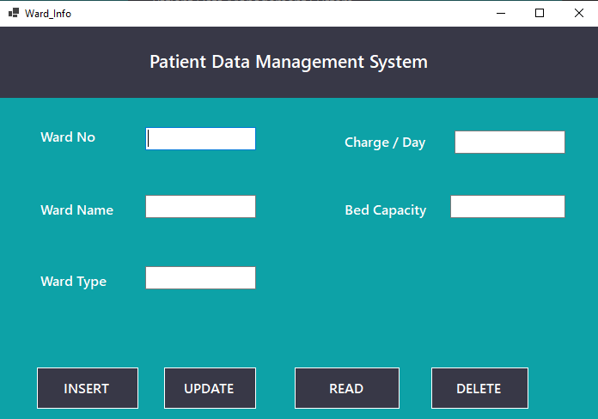

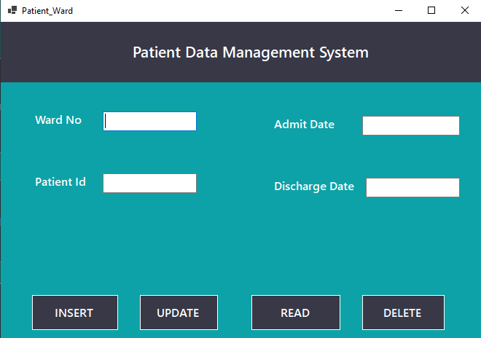

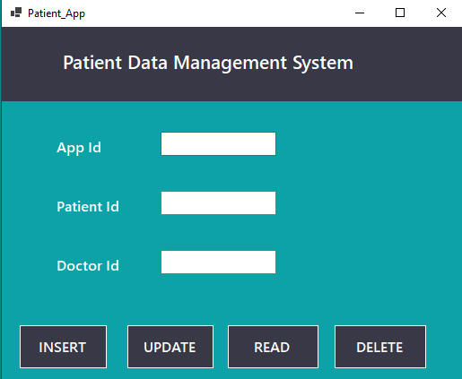

* Scope of the project

This management system is designed to provide an efficient, reliable, user-friendly and enhanced database application so that it eases the workload and lowers the chances of errors which obviously has greater probability to occur when being handled manually.

Here’s how each feature has its own scope:

Patient Registration: Allows patient to get registered when visiting for the first time and keeps the record for the future so that if same person visits, his/her data can be retrieved such as health record and medical history etc.

Patient Appointment:

Enable healthcare professionals to schedule, manage, and track patient appointments. Allow patients to book, reschedule, or cancel appointments through the system and Provide reminders and notifications to patients and healthcare providers.

Billing and Payment:

Automate the generation of patient bills based on services rendered, Calculate bill amounts accurately using procedures and functions, including fees, treatments, and medications.  
Electronic Health Records (EHR):

Store and manage comprehensive electronic health records for each patient. This will also Capture and track medical history, diagnoses, allergies, medications, and vital signs and Allow healthcare providers to access and update patient records securely.

Patient Ward Management:  
Manage patient ward information, including admission, discharge, and transfer between wards. This also monitor bed availability, occupancy, and bed assignments and obviously provide real-time updates on patient ward status and availability.

Reporting and Analytics:  
Generate reports and analytics on various aspects, such as appointment statistics, billing summaries, patient details, doctor details and wards details using triggers, functions, procedures and views.

User-Friendly Interface:

Design an intuitive and user-friendly interface for easy navigation and efficient use of the system and ensure responsiveness across different devices and screen sizes.

# Methodology:

* Business Rules to be applied in the DBMS

**Patient Registration:-**

* Patients should be assigned a unique ID for easy identification and tracking.
* Duplicate registrations should be prevented to maintain accurate patient records.

**Appointment Scheduling:-**

* Appointments should be scheduled based on the availability of doctors.
* Patients should be allocated appropriate time slots

**Billing:-**

* Accurate billing information must be recorded for each patient

**Test Results:-**

* Test results should be recorded and made available to authorized healthcare providers.
* Entity Relationship Diagram

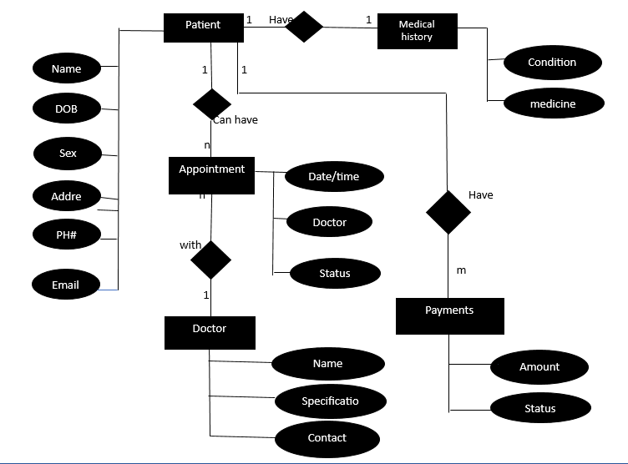

# Implementation:

* Conceptual to Logical Mapping
* Normalized Tables up to BCNF (SQL Server Schema Diagram)

**Billing:-**

**FD:-**

Bill ID -> Bill Amount, Bill Date

Patient ID -> Name, Phone, Age, Gender

**1st NF:-**

Atomic Values

Key -> Bill ID _ Patient ID

**2nd NF:-**

Patient-Info (Patient ID -> Name, Phone, Age, Gender)

Bill-Info (Bill ID -> Amount, Bill Date)

Patient-Bill (Patient ID _ Bill ID)

**Appointments:-**

**FD:-**

Patient ID -> Name, Phone, Age, Gender

App ID -> App Date, Time Slot, Doctor ID, Doctor Name

**1st NF:-**

Atomic Values

Key -> Patient ID _ App ID

**2nd NF:-**

Patient-Info (Patient ID -> Name, Phone, Age, Gender)

App-Info (App Date, Time Slot, Doctor ID, Doctor Name)

**3rd NF:-**

Patient-Info (Patient ID -> Name, Phone, Age, Gender)

App-Info (App Date, Time Slot, Doctor ID, Doctor ID)

Doctor-Info (Doctor ID -> Doctor Name)

Patient-App-Doctor (Patient ID _ Doctor ID _ App ID)

**Patient Ward:-**

**FD:-**

Ward No -> Ward Type, Charge

Patient ID -> Name, Phone, Age, Gender

Ward No _ Patient ID -> admit Date, discharge Date

**1st NF:-**

Atomic Values

Key -> Ward No _ Patient ID

**2nd NF:-**

Patient-Info (Patient ID -> Name, Phone, Age, Gender)

Ward-Info (Ward No -> Ward Type, Charge)

Patient-Ward (Ward No _ Patient ID -> admit Date, discharge Date)

* Code snippets of DDL/DML/Views/Stored Procedures/Stored Functions/Triggers

**Views:-**

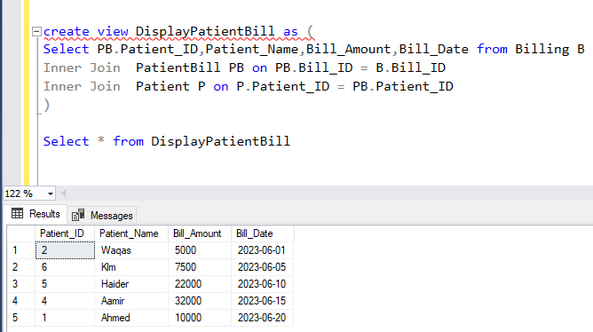

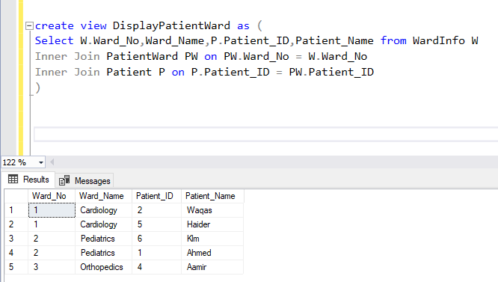

**Stored Procedures:-**

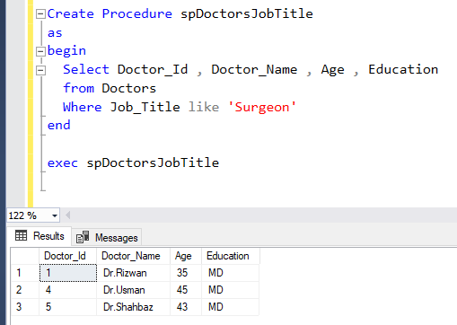

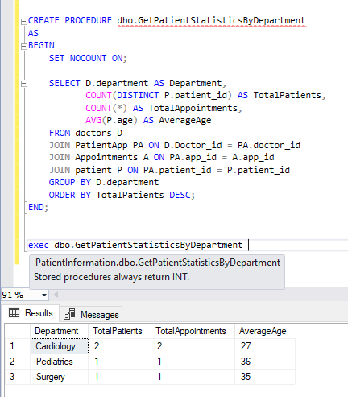

**Functions:-**

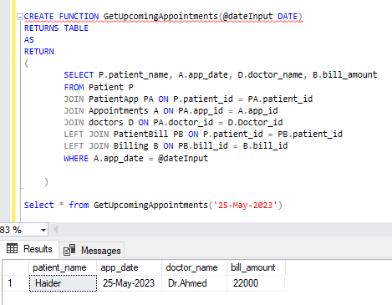

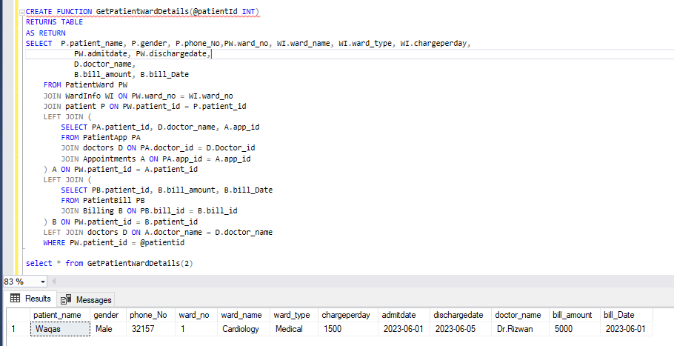

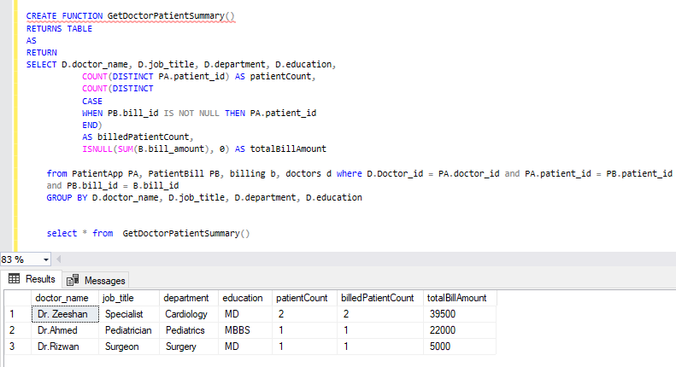

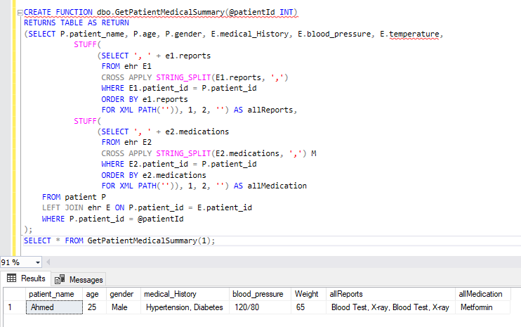

**Triggers:-**

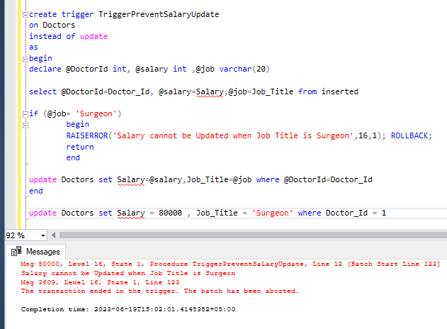

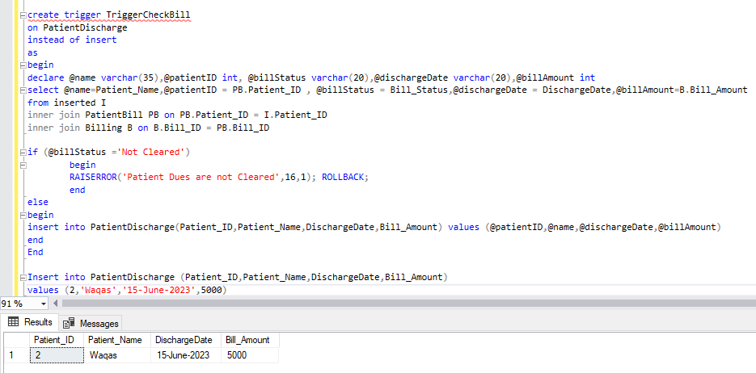

# Conclusion:

* Evaluation of the project's success in meeting its objectives

The success of the project was evaluated based on its objectives to determine the extent to which they were achieved.

The objective of efficient patient registration was evaluated by the analyzing the fact that these details may be helpful for later checkups and medical history or to whom that patient already had appointments and much more

The objective of efficient appointment stuff was evaluated by analyzing the impact of the system on streamlining the appointment scheduling process, reducing scheduling errors, and improving overall efficiency. The evaluation considered metrics such as the reduction in appointment scheduling time, the number of successful appointments booked through the system.

The objective of accurate billing generation was assessed by examining the system's ability to calculate bill amounts accurately, generate itemized bills, and track payments effectively. The evaluation included metrics such as the accuracy of bill calculations and the satisfaction of users with the billing process facilitated by the system.

The objective of comprehensive electronic health records (EHR) was evaluated by analyzing the system's capability to capture, store, and retrieve patient health records accurately and efficiently. The evaluation involved assessing the completeness and accuracy of the recorded information, the time taken to access and update patient records, and feedback from users regarding the usability of the EHR module.

The success of patient ward management was evaluated by analyzing the system's effectiveness in managing patient ward information, including admission, discharge, and bed occupancy tracking. The evaluation considered metrics such as the average length of patient stays, the utilization rates of beds, and the satisfaction of users with the ward management functionalities provided by the system.

Finally, the project's impact on improving communication and collaboration among healthcare providers was assessed. The evaluation focused on the system's ability to facilitate effective communication, enhance coordination, and support informed decision-making

By conducting this evaluation, the project team gained insights into the extent to which the project successfully met its objectives and delivered the intended functionalities and benefits.

* Screenshots of major modules’ outputs

